**NST31042 – Practical for Scaling and Connecting**

Lab Report-10

1. Registration number: SEU/IS/19/ICT/046
2. Academic Year: 2019/2020
3. Practical Number: 10

**Title:** Static NAT Configuration

Aim

1. Configure and Familiar with Static NAT Configuration for IPv4

**Task:**

1. Build the Network and Configure Basic Device Settings
2. Configure and verify Static NAT for IPv4
3. Verify NAT **Introduction:**

Static NAT creates a one-to-one mapping between private IP addresses on your internal network and public IP addresses. This allows specific devices on your network, like web servers, to be directly reachable from the internet.

**Question 1**

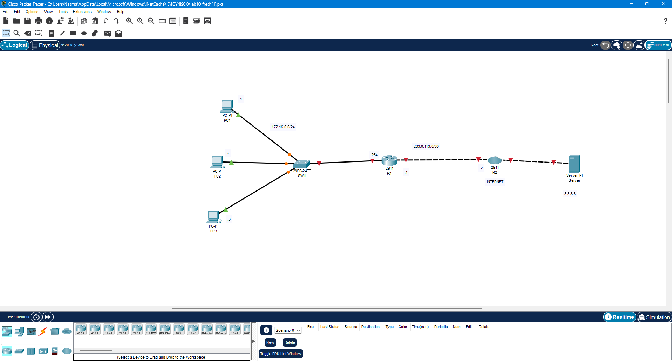

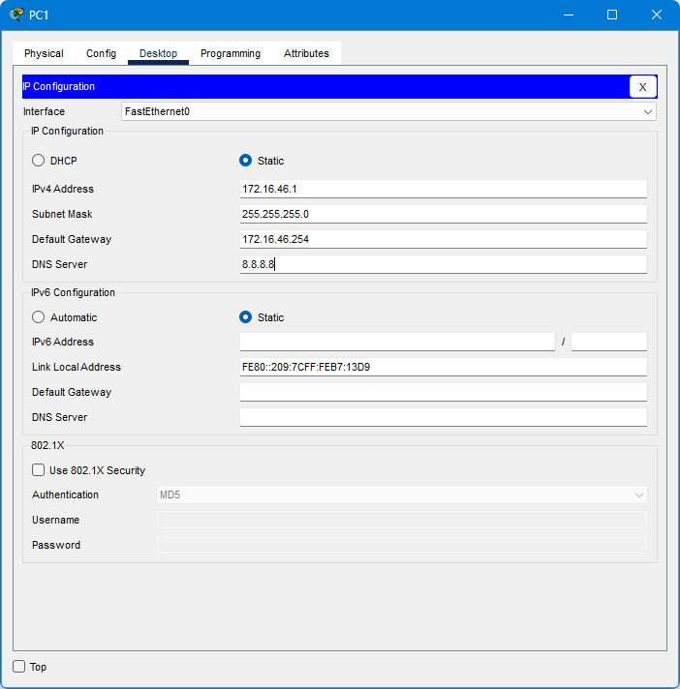

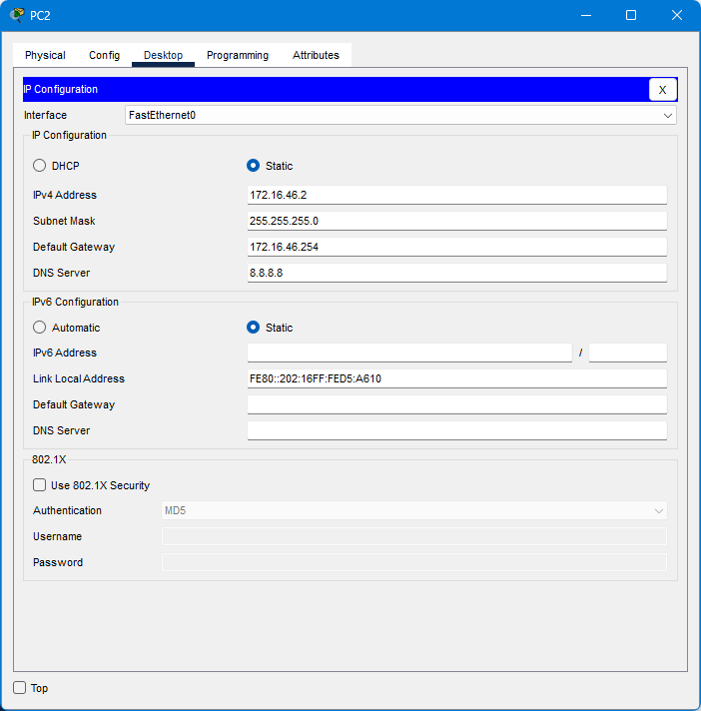

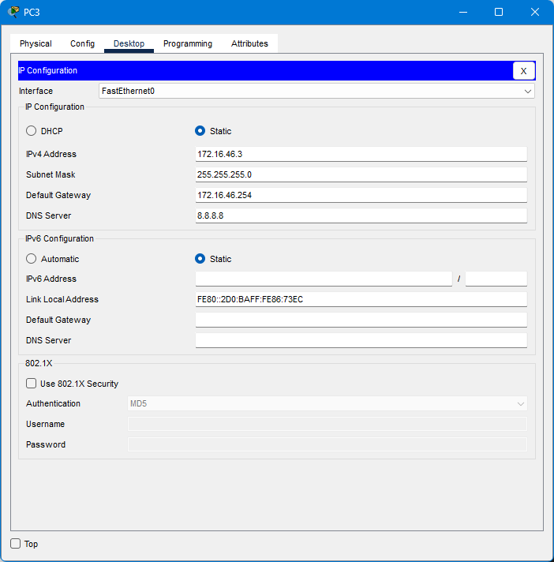

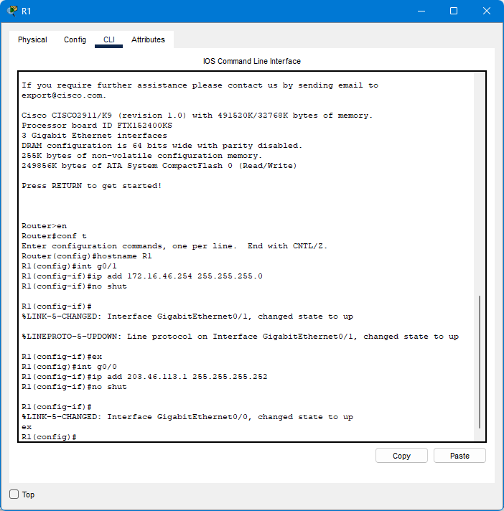

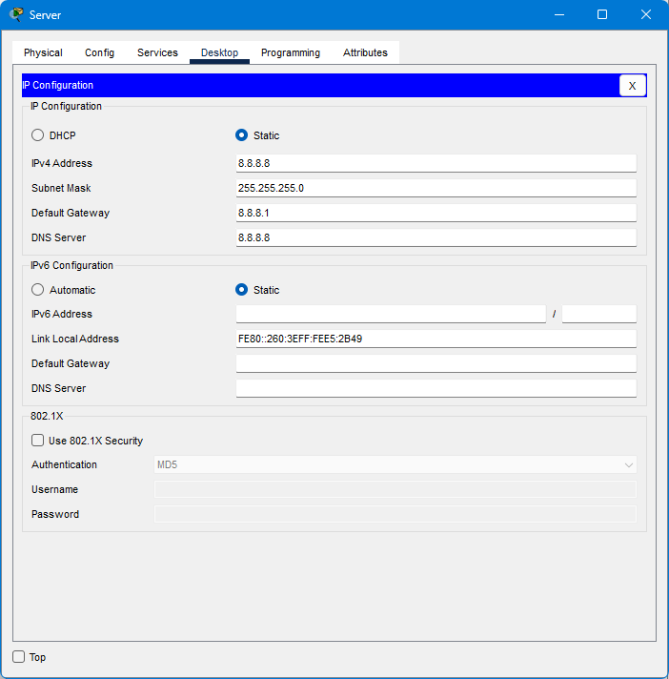

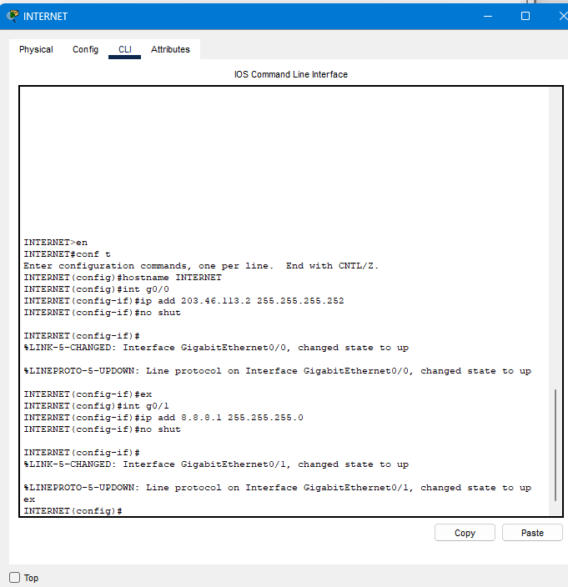

3. Create loopback interface in "INTERNET"and assign ip address "172.217.175.238/32"

4. On DNS service and name-google.com Address-172.217.175.238

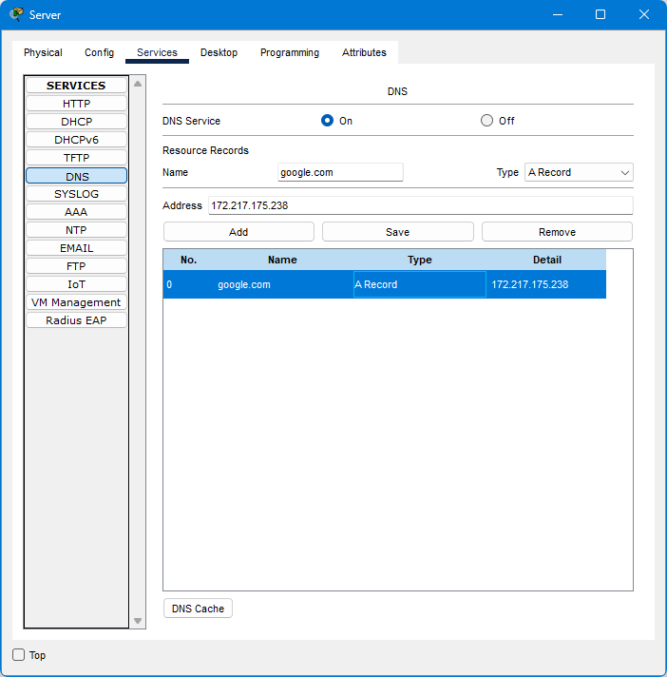

5. Create ip route in R1 and INTERNET > R1-0.0.0.0 0.0.0.0 203.0.113.2

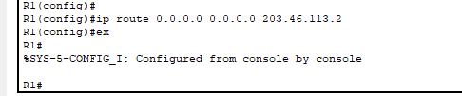

INTERNET-100.0.0.0 255.255.255.0 203.0.113.1

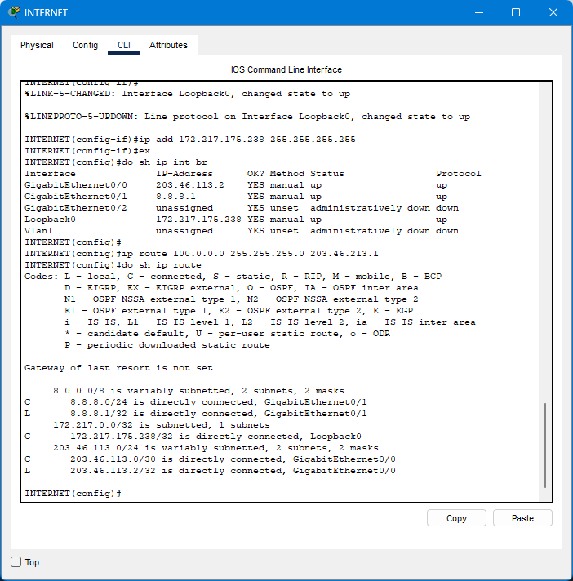

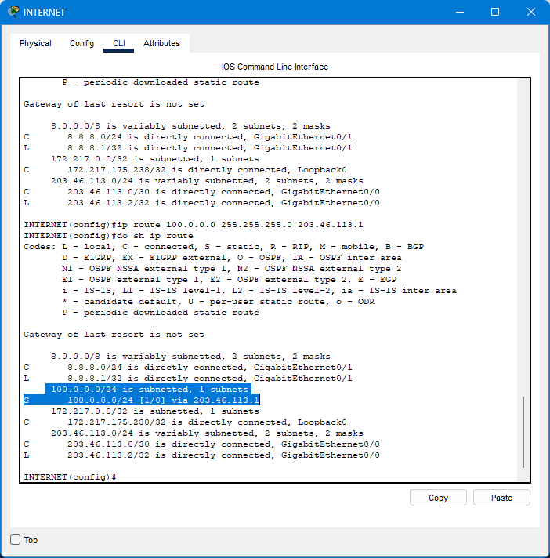

6. Attempt to ping from PC1 to 8.8.8.8. Does the ping work?

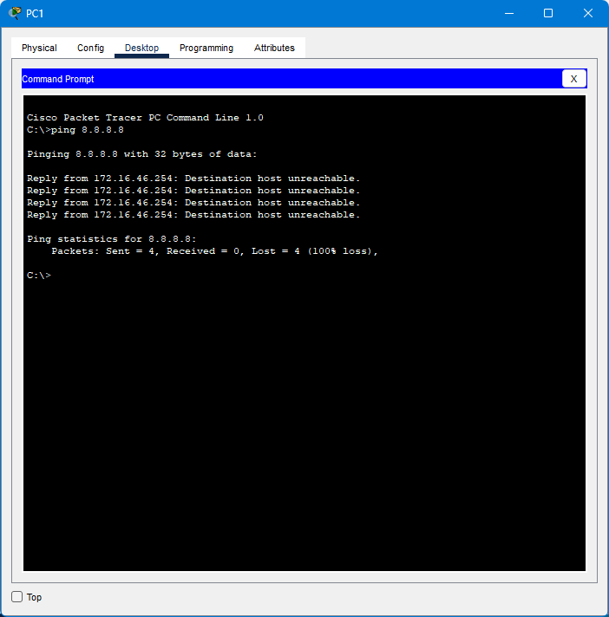

Configure static NAT on R1. > Configure the appropriate inside/outside interfaces

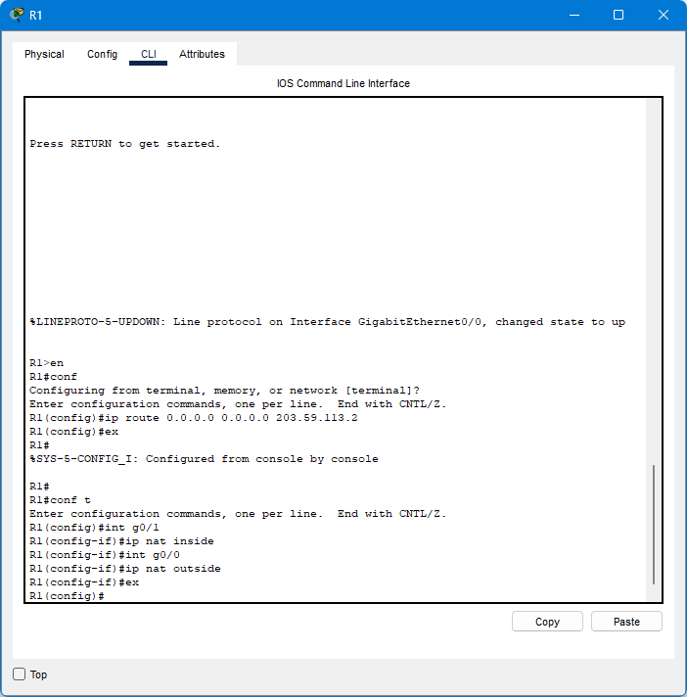

Map the IP addresses of PC1, PC2, and PC3 to 100.0.0.x/24

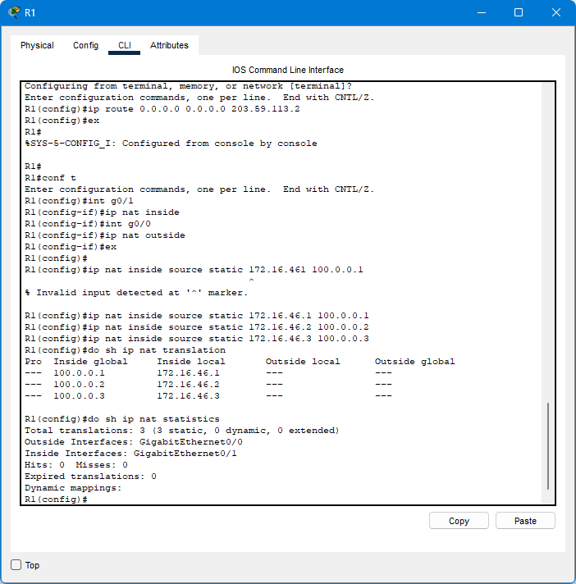

Ping 8.8.8.8 from PC1 again. Does the ping work?

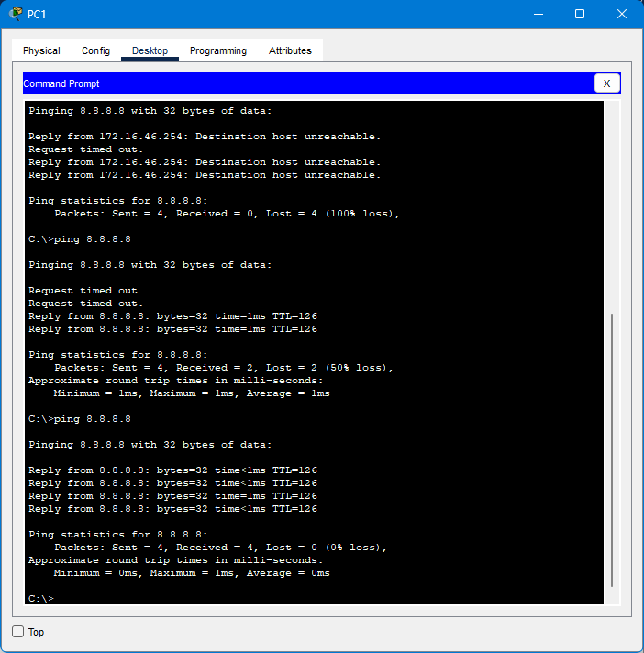

Ping google.com from each PC, and then check the NAT translations on R1.

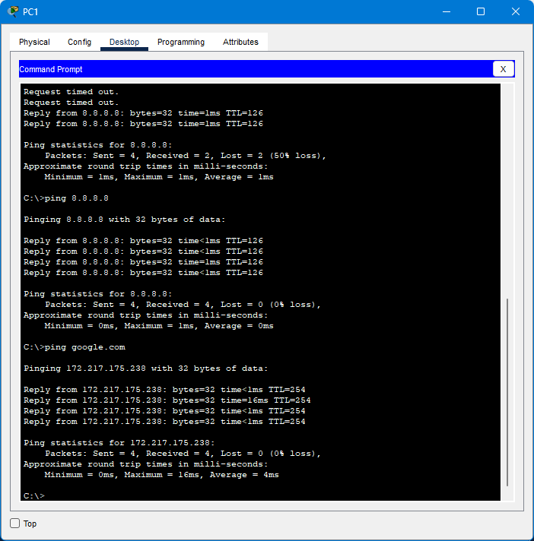

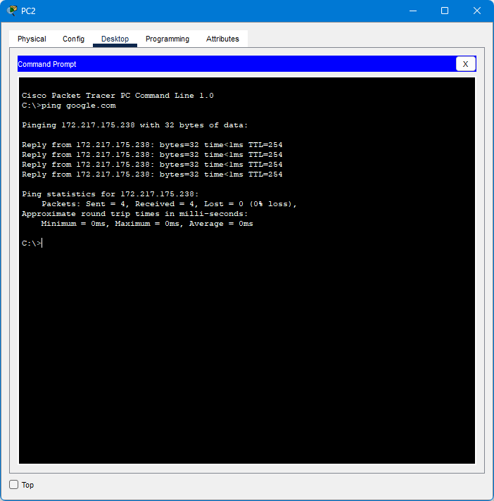

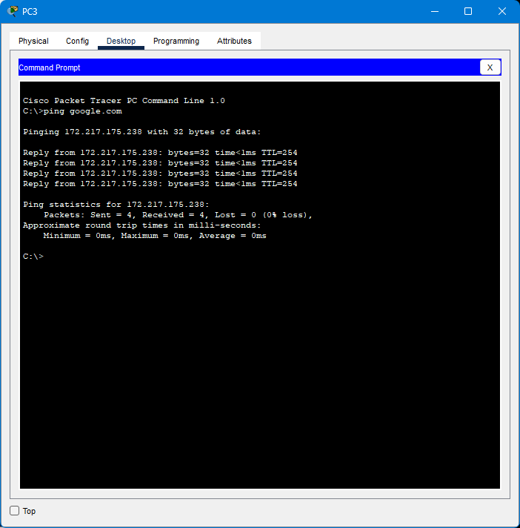

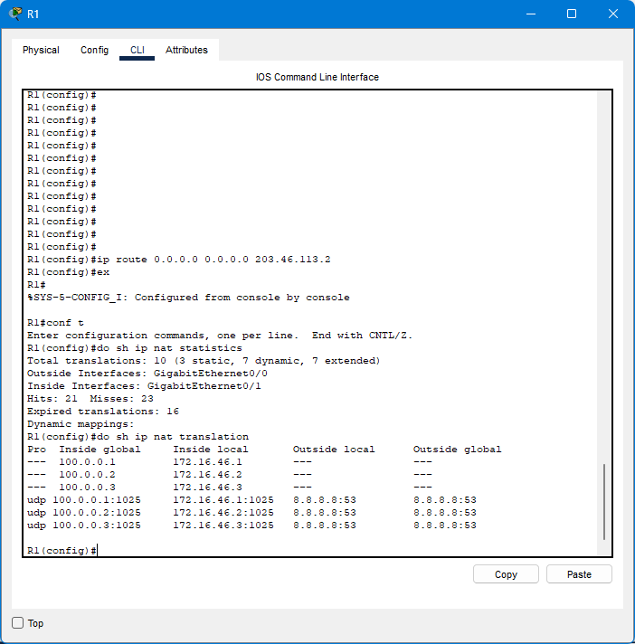

Clear the NAT translations on R1. Which entries remain?

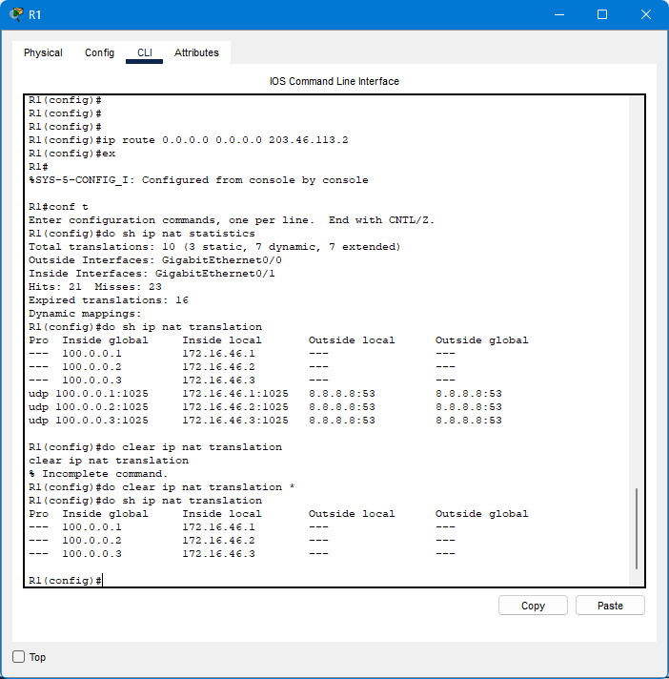

Discussion:

1. In this lab session. I had understood, Static NAT Configuration for IPV4.
2. With static NAT, public IP addresses and private IP addresses on your internal network are mapped one to one. This enables direct internet access to certain devices on your network, such as web servers.
3. Finally, I was ping successfully.

Reference:

* Today’s practical session of lecture (4th Apr 2024)
* https://www.computernetworkingnotes.com/ccna-study-guide/how-to-configure-static-nat-in-cisco-router.html